H bridge has the 4 switches for microcontroller to control which way robot drives

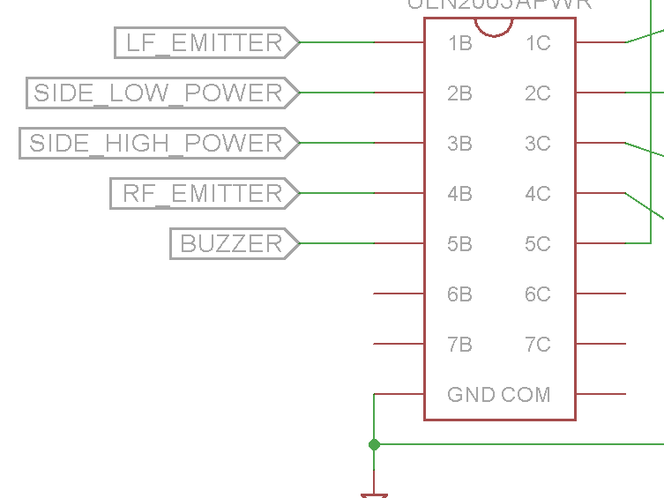

send out signals using these 5 pins